Siddaganga Institute of Technology, Tumakuru
(An Autonomous Institution affiliated to Visvesvaraya Technological University, Belagavi, Approved by AICTE, New Delhi, Accredited by NAAC and ISO 9001:2015 certified)

ANN & DL PROJECT REPORT
ON
“DISEASE DETECTION IN APPLE LEAVES”
submitted
in the partial fulfillment of the requirements for VII semester
Bachelor of Engineering
In
Artificial Intelligence and Data Science
by
ASHUTOSH N B GOWDA – 1SI20AD005
AMOGHA GANESH T M – 1SI20AD003



Department of Computer Science and Engineering
(Program Accredited by NBA)
Branch: Artificial Intelligence and Data Science Academic Year: 2023-24
Siddaganga Institute of Technology, Tumakuru
(An Autonomous Institution affiliated to Visvesvaraya Technological University, Belagavi, Approved by AICTE, New Delhi, Accredited by NAAC and ISO 9001:2015 certified)
Department of Computer Science and Engineering


CERTIFICATE

This is to certify that open ended problem titled “Disease Detection in Apple
leaves” is a bonafide work carried out by Ashutosh N B Gowda(1SI20AD005), Amogha Ganesh TM(1SI20AD003) of VII semester Bachelor of Engineering in Computer Science and Engineering of the SIDDAGANGA INSTITUTE OF TECHNOLOGY (An Autonomous Institution, affiliated to VTU, Belagavi, Approved by AICTE, New Delhi, Accredited by NAAC and ISO 9001:2015 certified) during the academic year 2021-2022.
.

Name of the Panel Members Signature with Date
- Dr.Shobha K

TABLE OF CONTENTS:

Sl.No. | Contents | Page No.
1 | Abstract & Technologies used | 04
2 | Preparation of data | 05
3 | Preparation of model | 07
4 | Training of model | 09
5 | Creating web application | 10
6 | Web Interface | 18
7 | Conclusion | 19

ABSTRACT
Detection of a wrong disease may impact agricultural crops that may lead to misuse of chemicals leading to the emergence of resistant pathogen strains, increased input costs, and more outbreaks with significant economic loss and environmental impacts.
Current disease detection is based on human scouting. This is time consuming and expensive, and although computer-vision based models have the promise to increase efficiency, the great variance in symptoms due to age of infected tissues, genetic variations, and light conditions within trees decreases the accuracy of detection. Objectives of this project is to train a model using images in a dataset.

TECHNOLOGY USED
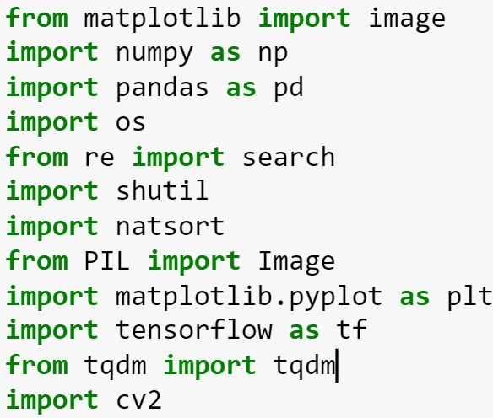

- Matplotlib -> It is used to work with graph
- Numpy -> It is used to work with matrix transformation and multidimensional array
objects
- Pandas -> It is for data manipulation and analysis and it is used in machine learning
Tasks
- Re(regex) -> It is used to work with strings
- Shutil -> It is used for high level operations on files and collection of files
- Natsort -> It is used for sorting
- PIL -> It is a library that adds image processing capabilities
- Tensorflow -> It is an end-to-end open-source platform for machine learning
- Tqdm -> It is used for creating progress meters or progress bars
- Cv2 -> It is open-source library for computer vision

PREPARATION OF DATA
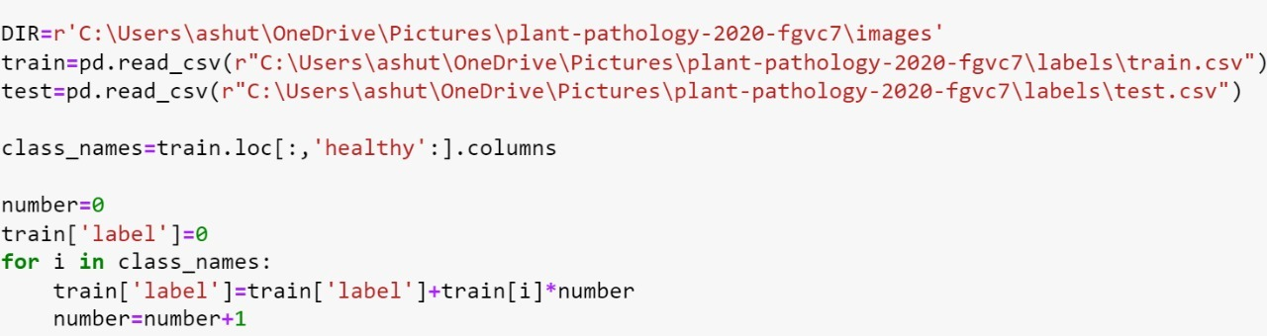

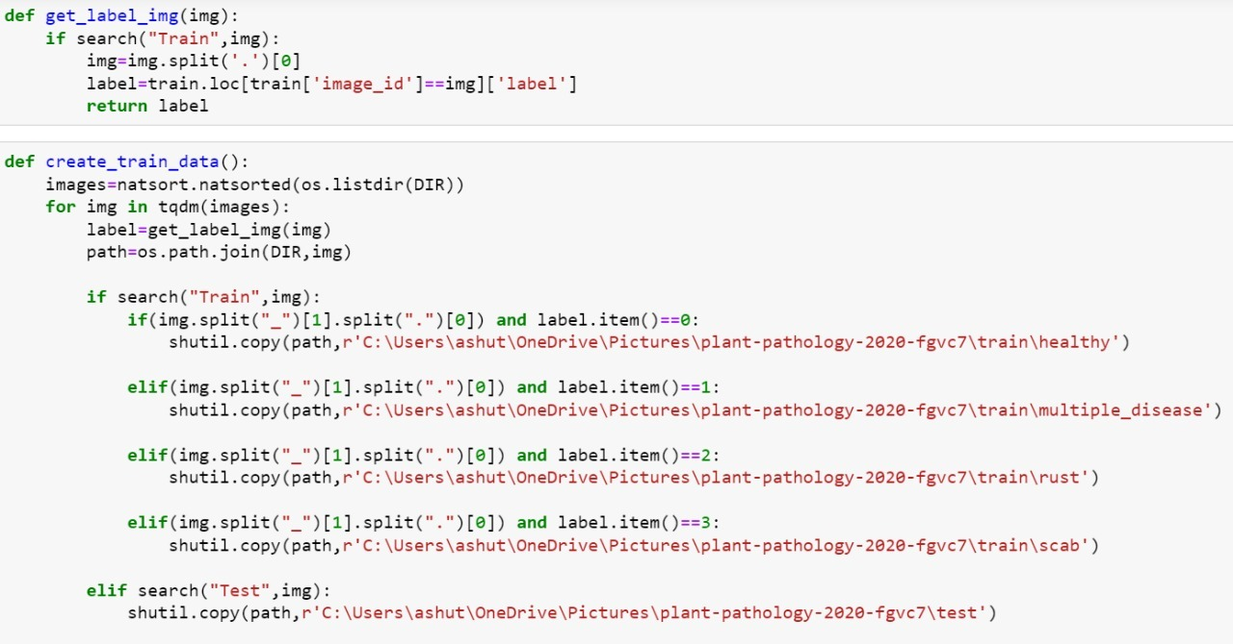

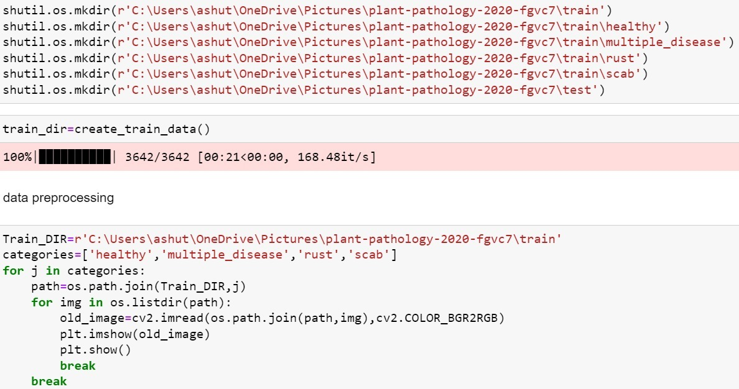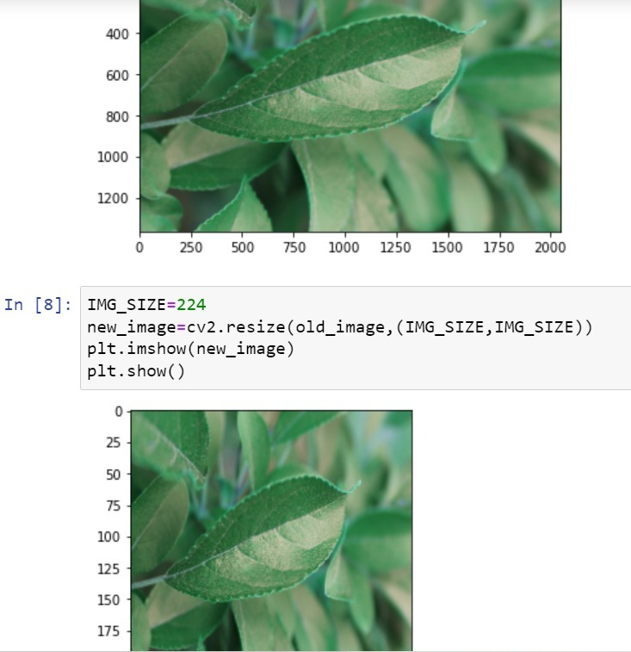

- Preparing the data is important since it is fed as input to the model to train.
- Here in this project the whole data is in the same folder.
- But to train the model, we need images in different folders where each images belong to the same catogories .
- We have used regular expression to perform operation on searching and splitting of strings.
- We have used shutil to perform complex operations on image files and image sets.
- At last image size has been fixed same for all the image sets, so it can be fed as input to the model.

PREPARATION OF MODEL
Tensorflow is imported to create the model. Images are fed as input to train and test the model.
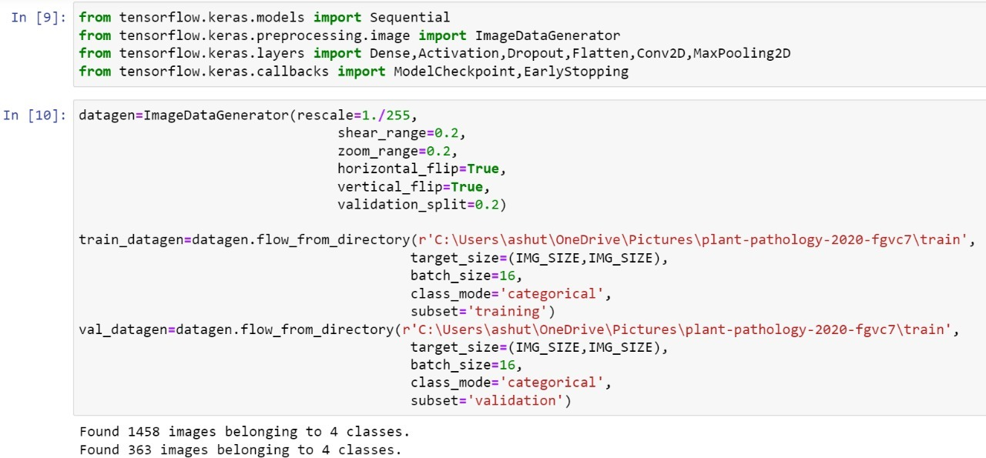

Model is created of the type 'Sequential'
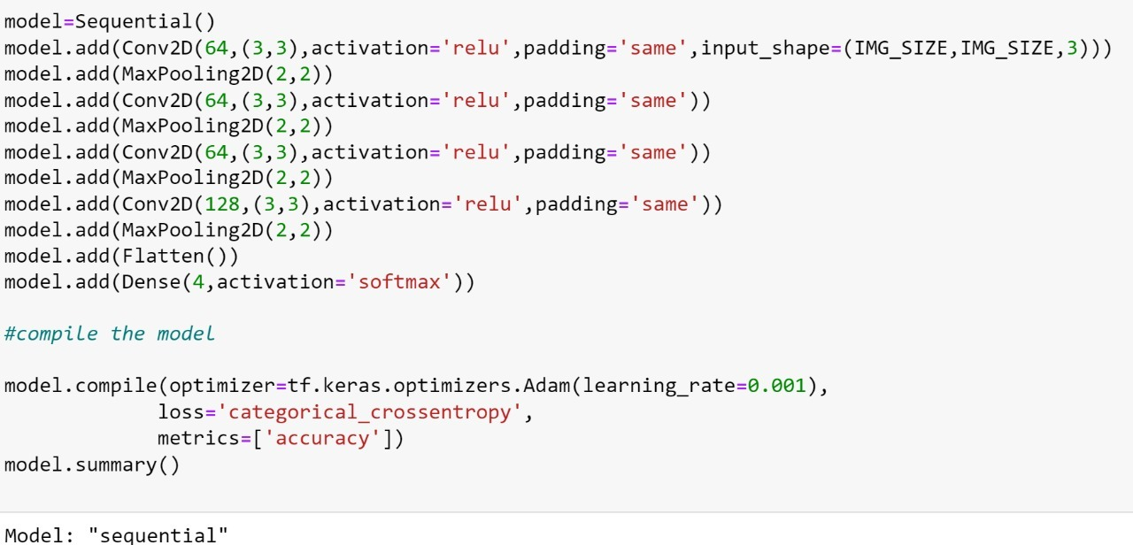
MODEL SUMMARY
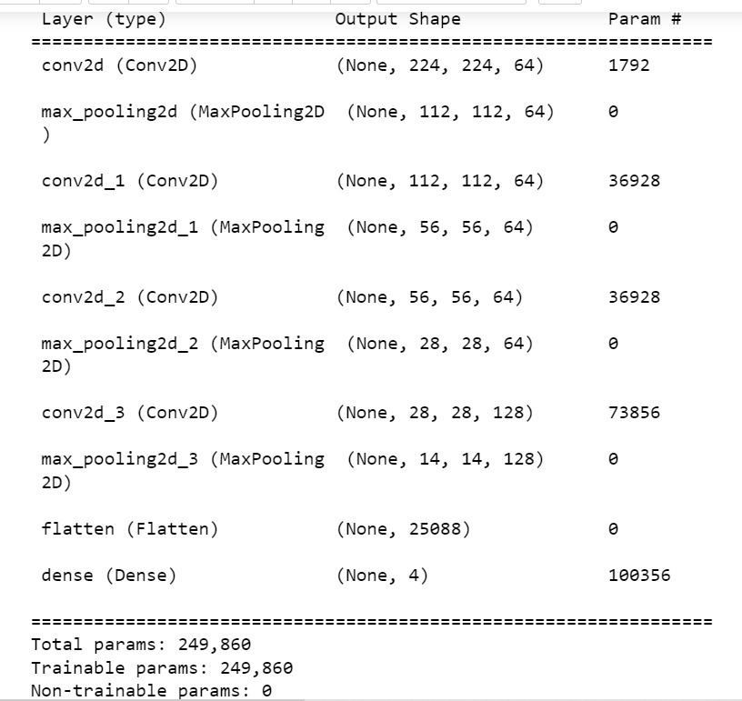

MODEL IS READY FOR TRAINING
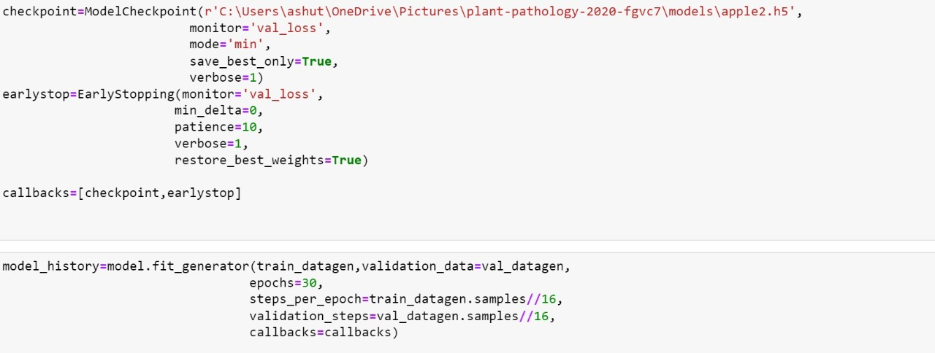
TRANNING
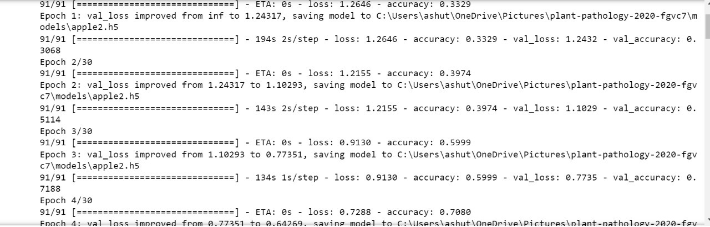
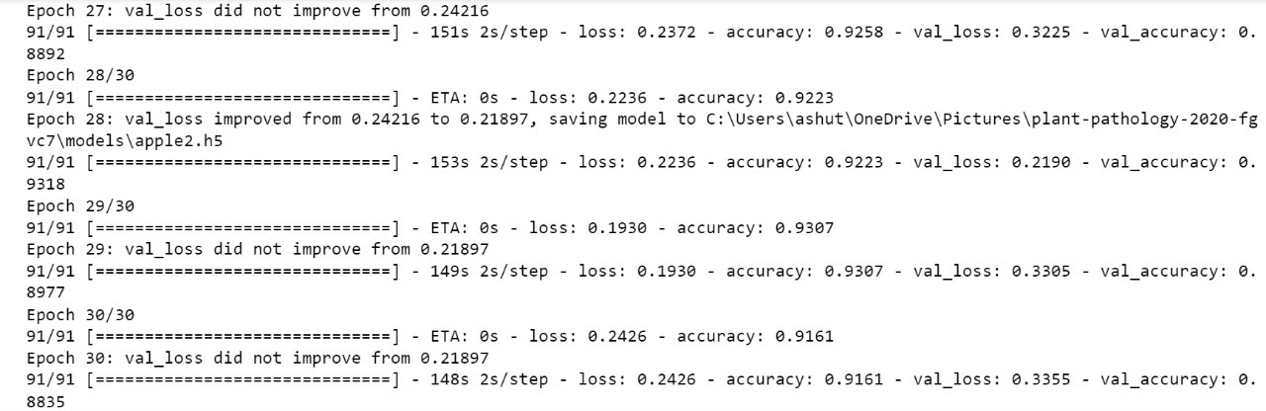
Here the model is training, as you can see in the first image, the loss is more and the accuracy is very less. But as the model trains 30 epochs, the loss decreases and the accuracy increases. Finally the model is saved as .h25 file.

CREATING A WEB APPLICATION
A web application is created using flask for backend and html,css,javascript for front end. Below are the code of python, html, css, javascript .
PYTHON PROGRAM
from flask import Flask,render_template,request
import numpy as np
import os
from tensorflow.keras.models import load_model
from tensorflow.keras.preprocessing import image
from werkzeug.utils import secure_filename

#define the flask app
app=Flask(_name_)

#load the model
model=load_model('models/apple2.h5')

def model_predict(img_path,model):
test_image=image.load_img(img_path,target_size=(224,224))
test_image=image.img_to_array(test_image)
test_image=test_image/255
test_image=np.expand_dims(test_image,axis=0)
result=model.predict(test_image)
return result

@app.route('/',methods=['GET'])
def index():
return render_template('index.html')

@app.route('/predict',methods=['GET','POST'])
def upload():
if request.method=='POST':
#get file from post request
f=request.files['file']

#save file to uploads folder
basepath=os.path.dirname(os.path.realpath('_file_'))
file_path=os.path.join(basepath,'uploads',secure_filename(f.filename))
f.save(file_path)

#make prediction
result=model_predict(file_path,model)

categories=['The apple leaf is healthy','This apple leaf has multiple diseases','This apple leaf has rust disease: Apply SERENADE fungicide to prevent disease','This apple leaf has scab: Apply liquid copper soap on the leaf']

#process result for human form
pred_class=result.argmax()
output=categories[pred_class]
return output
return None

if _name=='main_':
app.run(debug=False,port=5500)

HTML FILES
<html lang="en">

<head>
<meta charset="UTF-8">
<meta name="viewport" content="width=device-width, initial-scale=1.0">
<meta http-equiv="X-UA-Compatible" content="ie=edge">
<title>Apple disease detection</title>
<link href="https://cdn.bootcss.com/bootstrap/4.0.0/css/bootstrap.min.css" rel="stylesheet">
<script src="https://cdn.bootcss.com/popper.js/1.12.9/umd/popper.min.js"></script>
<script src="https://cdn.bootcss.com/jquery/3.3.1/jquery.min.js"></script>
<script src="https://cdn.bootcss.com/bootstrap/4.0.0/js/bootstrap.min.js"></script>
<link href="{{ url_for('static', filename='css/main.css') }}" rel="stylesheet">
</head>

<body>
<nav class="navbar navbar-dark bg-dark">
<div class="container">
<a class="navbar-brand" href="#">Apple disease detection</a>
</div>
</nav>
<div class="container">
<div id="content" style="margin-top:2em">{% block content %}{% endblock %}</div>
</div>
</body>

<footer>
<script src="{{ url_for('static', filename='js/main.js') }}" type="text/javascript"></script>
</footer>

</html>

{% extends "base.html" %} {% block content %}

<h2>Upload jpg image of apple leaf</h2>

<div>
<form id="upload-file" method="post" enctype="multipart/form-data">
<label for="imageUpload" class="upload-label">
Choose file
</label>
<input type="file" name="file" id="imageUpload" accept=".png, .jpg, .jpeg">
</form>

<div class="image-section" style="display:none;">
<div class="img-preview">
<div id="imagePreview">
</div>
</div>
<div>
<button type="button" class="btn btn-primary btn-lg " id="btn-predict">Predict!</button>
</div>
</div>

<div class="loader" style="display:none;"></div>

<h3 id="result">
<span> </span>
</h3>

</div>

{% endblock %}

CSS FILE
.img-preview {
width: 256px;
height: 256px;
position: relative;
border: 5px solid #F8F8F8;
box-shadow: 0px 2px 4px 0px rgba(0, 0, 0, 0.1);
margin-top: 1em;
margin-bottom: 1em;
}

.container {
display: flex;
justify-content: center;
border: solid;
border-color: #f3f3f3;
}

.img-preview>div {
width: 100%;
height: 100%;
background-size: 256px 256px;
background-repeat: no-repeat;
background-position: center;
}

input[type="file"] {
display: none;
}

.upload-label {
display: inline-block;
padding: 12px 30px;
background: #39D2B4;
color: #fff;
font-size: 1em;
transition: all .4s;
cursor: pointer;
}

.upload-label:hover {
background: #34495E;
color: #39D2B4;
}

.loader {
border: 8px solid #f3f3f3;
/* Light grey */
border-top: 8px solid #3498db;
/* Blue */
border-radius: 50%;
width: 50px;
height: 50px;
animation: spin 1s linear infinite;
}

@keyframes spin {
0% {
transform: rotate(0deg);
}
100% {
transform: rotate(360deg);
}
}

JAVA SCRIPT FILE
$(document).ready(function() {
// Init
$('.image-section').hide();
$('.loader').hide();
$('#result').hide();

// Upload Preview
function readURL(input) {
if (input.files && input.files[0]) {
var reader = new FileReader();
reader.onload = function(e) {
$('#imagePreview').css('background-image', 'url(' + e.target.result + ')');
$('#imagePreview').hide();
$('#imagePreview').fadeIn(650);
}
reader.readAsDataURL(input.files[0]);
}
}
$("#imageUpload").change(function() {
$('.image-section').show();
$('#btn-predict').show();
$('#result').text('');
$('#result').hide();
readURL(this);
});

// Predict
$('#btn-predict').click(function() {
var form_data = new FormData($('#upload-file')[0]);

// Show loading animation
$(this).hide();
$('.loader').show();

// Make prediction by calling api /predict
$.ajax({
type: 'POST',
url: '/predict',
data: form_data,
contentType: false,
cache: false,
processData: false,
async: true,
success: function(data) {
// Get and display the result
$('.loader').hide();
$('#result').fadeIn(600);
$('#result').text(' Result: ' + data);
console.log('Success!');
},
});
});
});

WEB INTERFACE
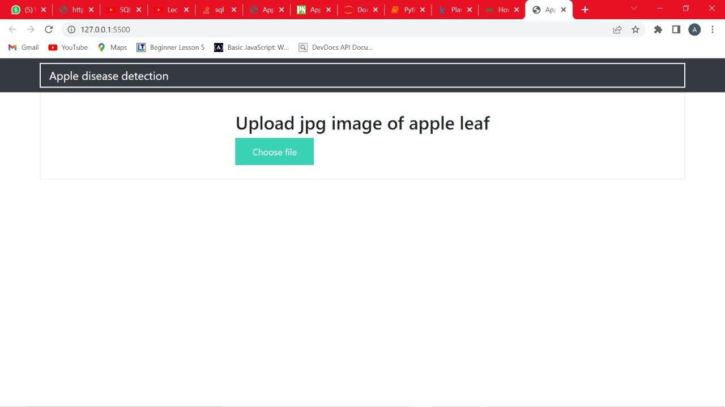

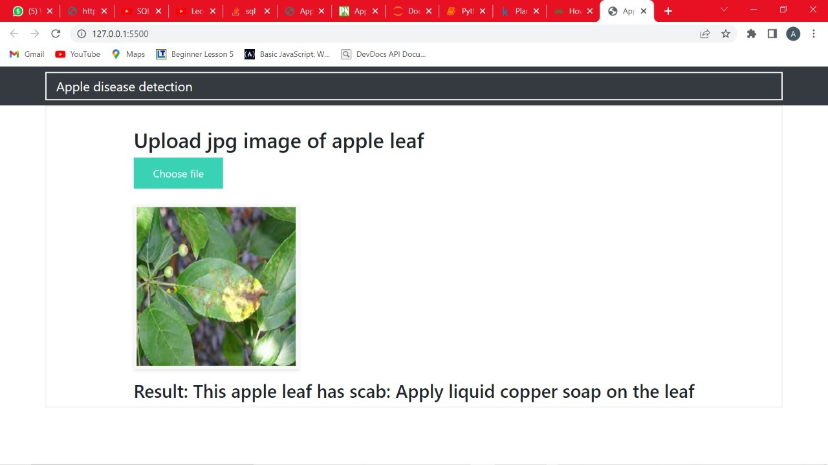

CONCLUSION
The model is successfully created, trained, and tested. Web application is created to interact with the user. User can upload a jpeg file of apple leaf; application predicts the disease and displays.

